**CERTIFICATE**

*This is to certify that Mr./Ms.* ***….... Hemil…Chovatiya.............*** *with enrolment no.* ***..........200303108003.................*** *has successfully completed* ***his****/her laboratory experiments in the*  ***Fundamental Of Software Engineering laboratory (203105255)***  *from the department of* ***........Information Technology(4ITA1)….….........*** *during the academic year* ***........2021-2022.........***



Date of Submission: ......................... Staff In charge: ...........................

Head of Department: ...........................................

**INDEX**

|  |  |  |  |  |  |  |  |
| --- | --- | --- | --- | --- | --- | --- | --- |
| **SR. NO.** | **TITLE** | **Number of hours** | **Page**  **No.** | **Performance date** | **Assessment date** | **Marks out 0f 10** | **Sign** |
| 1 | Project Definition and objective of the specified module and Perform Requirement Engineering Process. | 2 |  |  |  |  |  |
| 2 | Identify Suitable Design and Implementation model from the different software engineering models. | 2 |  |  |  |  |  |
| 3 | Prepare Software Requirement Specification (SRS) for the selected module. | 2 |  |  |  |  |  |
| 4 | Develop Software project management planning (SPMP) for the specified module. | 2 |  |  |  |  |  |
| 5 | Do Cost and Effort Estimation using different Software Cost Estimation models. | 2 |  |  |  |  |  |
| 6 | Prepare System Analysis and System Design of identified Requirement specification using structure design as DFD with data dictionary and Structure chart for the specific module. | 2 |  |  |  |  |  |
| 7 | Designing the module using Object Oriented approach including Use case Diagram with scenarios, Class Diagram and State Diagram, Collaboration Diagram, Sequence Diagram and Activity Diagram. | 2 |  |  |  |  |  |
| 8 | Defining Coding Standards and walk through. | 2 |  |  |  |  |  |
| 9 | Write the testcases for the identified module. | 2 |  |  |  |  |  |
| 10 | Demonstrate the use of different Testing Tools with comparison. | 2 |  |  |  |  |  |
| 11 | Define security and quality aspects of the identified module. | 2 |  |  |  |  |  |

**PRACTICAL 1**

**AIM: -** Project Definition and objective of the specified module and Perform Requirement Engineering Process.

**HOME SERVICE PROVIDER: -**

We understand your needs for small but difficult to solve issues like changing the broken tap of the kitchen or lamp in the study, making a fancy table from the waste wood, repairing the geyser, pest control, and lots more home services.

We know there are many ‘How-to’ guides on Google & YouTube, but professional assistance is needed to complete such tasks efficiently and correctly.

We are the best online service provider in India for any such issues at home, office, or any other place. You can book the services online, and our professional will be at your doorstep with the solution.

Take our online home services and spend the time with your beloved family as well as following your career/passion being stress-free.

**INNOVATIVE FEATURES OF THE SYSTEM: -**

1. Mobile response web design which allows the user to access the same site from any type of device like smartphone, tablets, smart tv, pc, laptop.
2. Provides the Services at Minimum charges & following the COVID-19 protocols.
3. It is the one stop solution for your everyday house chores whether it is related to electricity, earthing, plumbing, cleaning, repairing, or managing the stuff.
4. We want to become your all-time favorite and reliable directory with all important details and fair reviews when you are in a hurry or not in the mood to take any crap on your loving holiday.
5. We will help you to get services at your doorsteps, just like you get home deliveries of your favorite products.

**SCOPE OF THE SYSTEM: -**

1. We will only work in those areas where we are able to reach for examples cities and towns. We won’t be able to come at Villages.
2. Would likely to provide all the services regarding…

* CLEANING
* PLUMBING
* ELECTRICIAN
* PAINTER
* CARPENTER
* GARDENER
* TAILOR
* DRIVER
* COOK

3) It will be developed in CSS, HTML, JAVASCRIPT & BOOTSTRAP.

**MAIN MODULE OF THE SYSTEM: -**

1. Admin Module.
2. User Module.
3. Search and view operation by site visitor (guest) for the available services.
4. Advertisement about the various types of services.
5. Online Payment, Cash Payment etc.
6. Facility of House requirement services.

**REQUIREMENT OF SYSTEM: -**

**DEFINITION OF REQUIREMENT ANALYSIS:**

Analysis of system requirements involves a clear understanding of the application to be

developed with the view of removing all ambiguities from user perception.

**REQUIREMENT SPECIFICATION:**

* **Non-functional requirement:**

The non-functional requirements include those that are implicit and improve the quality of the software.

* **Security:**

There is a facility for security of data. Authenticated users can access the application.

* **Easy to use:**

The system is easy to use and a good GUI.

* **Reliability:**

Reliability is assured by carrying out several tests for various test data as well as real live data and the output result matches the actual result. The system has been tested thoroughly which is described in the testing part. Hence, the system is reliable. The system supports generation of the printed reports.

* **Functional Requirement:**

**1. USER LOGIN:**

This feature used by the user to login into system. They are required to enter user id and password before they are allowed to enter the system. The user id and password will be verified and if invalid id is their user is allowed to not enter the system.

**Requirements:**

* User id is provided when they register
* The system must only allow user with valid id and password to enter the system
* The system performs authorization process which decides what user level can access to.
* The user must be able to logout after they finished using system.

**2. ADMINISTRATOR:**

Administrator of the system has all the rights and authorities to view as well as to modify and update the system whenever required for example he can add, remove, edit, area, valid zip code list, categories.

**3. REGISTER A NEW USER:**

This feature can be performed by all users to register new user to create account

**Requirement:**

* System must be able to verify information
* System must be able to delete information if information is wrong
* System must be able to search the database based on select search type
* System must be able to filter book based on keyword entered
* System must be able to show the filtered book in table view

**4. SEARCH SERVICES:**

This feature is found in home services. We can search services based on user choices by agent name.

**Requirement: -**

* System must be able to search the database based on select search type
* System must be able to filter book based on keyword entered
* System must be able to show the filtered book in table view

|  |  |  |  |  |  |
| --- | --- | --- | --- | --- | --- |
|  | VIEW | SEARCHING | MODIFY | ADD | WRITE |
| ADMINISTRATOR | Y | Y | Y | Y | N |
| GUSET | Y | Y | N | Y | Y |

**5. REGISTER AS EMPLOYEE:**

This feature is used to register as new employee on the basis of their services skills.

**Requirement: -**

1. System must be able to verify information/document.
2. System must be able to not allow to same employee Id.
3. System must be able allow in registering at different services at one time.
4. **SEARCH SERVICE SPECIFICATION: -**

* In this feature user can be able to get services as per his requirement.
* **FEASIBILITY STUDY:**

Feasibility study is the study of the application to check whether the application made is feasible or not. It is very useful to check whether the application works as per requirement or not. It is undertaken to determine the possibility of developing completely new applications.

**There are four feasibility studies that are considered.**

* Technical feasibility
* Operational feasibility
* Implementation feasibility

1. **SEARCH EMPLOYEE DETAILS: -**

This feature is used to get details of employee to the customer only in an isolation for their security reason.

1. **MAKE PAYMENT: -**

This feature is used to get details of payment to the customer.

* **TECHNICAL FEASIBILITY:**

1. It determines that work for the project is done with the present equipment and existing software technology.
2. As suggested for technical feasibility services will be user friendly and has a better GUI.
3. Does the proposed equipment have the technical capacity to hold the data required to use the new system?
4. Are there technical guarantees of accuracy, reliability, ease of access and data security.

* **OPERATIONAL FEASIBILITY:**

It covers mainly two aspects. It determines how the proposed system will fill in the current operation and what will happen if the job retraining and reconstructing may be needed at the end of the implementation system. The operational feasibility checks whether the user who is going to be using the system is able to work with the software in which the system is coded! System is very user friendly. Level of security and any other access control constraints are high.

* **IMPLEMENTATION FEASIBILITY:**
* As we have mentioned that we are going to use PHP, HTML, CSS, MYSQL to develop this project, we found that these technologies are easy to learn and then use.
* There is no copyright issue we face in development.
* We can use any hardware configuration of pc/laptop to complete development of this project.
* Once project is developed, it can be hosted on any web server with any operating system.
* **FEATURES OF THE SYSTEM:**
* Also provides and interacting chat box where they are also given suggestion on the base of user’s interest.
* Users can also read and write the reviews about the book.
* There is also a feature in which fine will be calculate automatically.
* Also tracks the user’s record.
* **SYSTEM REQUIREMENT STUDY AND ASSUMPTION:**
* Hardware requirements

The online system that we have built requires some specific hardware configuration; I have mentioned the basic minimum hardware recommendations to run the system adequately. Any higher configuration hardware would only add to the performance of the system. the minimum hardware would only add to the performance of the system. The minimum hardware requirements to run the system properly are as follows.

* 20 GB hard disk
* 512 DDR RAM
* Network card/network connection
* 1.4 GHZ processor
* Software requirements
* Operating System: any modern operating system like window, Linux, MACOS
* Web Server: Internet Information Services (IIS) Server or Apache.
* Database: MySQL
* Server-side scripting language: PHP
* Operating System: any modern operating system like window, Linux, MACOS
* Web Browser: any modern browser like Firefox Mozilla / Internet Explorer.
* Technology used for development
* Front – End: HTML, CSS, JS, AJAX, BOOTSTRAP
* Back – End: PHP, MYSQL
* Tools: Notepad++/Sublime, Amp
* Operating System:
* Operating System: any modern operating system like window, Linux, MACOS.

**PRACTICAL 2**

**AIM: Identify Suitable Design and Implementation model from the**

**Different Software engineering models.**

* **LIST OF MODELS:**
* Linear Sequential Waterfall model
* V-Model
* Prototype Model
* RAD Model.
* Evolutionary Software Process Model
* Incremental Model
* Spiral Model
* Iterative Model

**1.** **Linear Sequential Waterfall Model:**

The Waterfall Model was the first Process Model to be introduced. It is also referred to as a **linear-sequential life cycle model**. It is very simple to understand and use. In a waterfall model, each phase must be completed before the next phase can begin and there is no overlapping in the phases. The Waterfall model is the earliest SDLC approach that was used for software development. The waterfall Model illustrates the software development process in a linear sequential flow. In this waterfall model, the phases do not overlap.

**2.V-Model:**

The V-model is an SDLC model where execution of processes happens in a sequential manner in a V-shape. It is also known as **Verification and Validation model**. The V-Model is an extension of the waterfall model and is based on the association of a testing phase for each corresponding development stage. This means that for every single phase in the development cycle, there is a directly associated testing phase. This is a highly-disciplined model and the next phase starts only after completion of the previous phase.

**3. Prototype Model:**

The prototype model requires that before carrying out the development of actual software, a working prototype of the system should be built. A prototype is a toy implementation of the system. A prototype usually turns out to be a very crude version of the actual system, possible exhibiting limited functional capabilities, low reliability, and inefficient performance as compared to actual software. In many instances, the client only has a general view of what is expected from the software product.

**4.RAD Model:**

The **RAD (Rapid Application Development)** model is based on prototyping and iterative development with no specific planning involved. The process of writing the software itself involves the planning required for developing the product. Rapid Application Development focuses on gathering customer requirements through workshops or focus groups, early testing of the prototypes by the customer using iterative concept, reuse of the existing prototypes (components), continuous integration and rapid delivery.

**5. Incremental Model :**

Incremental Model is a process of software development where requirements divided into multiple standalone modules of the software development cycle. In this model, each module goes through the requirements, design, implementation and testing phases. Every subsequent release of the module adds function to the previous release. The process continues until the complete system achieved.

**6.Spiral Model :**

The spiral model combines the idea of iterative development with the systematic, controlled aspects of the waterfall model. This Spiral model is a combination of iterative development process model and sequential linear development model i.e. the waterfall model with a very high emphasis on risk analysis. It allows incremental releases of the product or incremental refinement through each iteration around the spiral.

**7. Iterative Model:**

In the Iterative model, iterative process starts with a simple implementation of a small set of the software requirements and iteratively enhances the evolving versions until the complete system is implemented and ready to be deployed. An iterative life cycle model does not attempt to start with a full specification of requirements. Instead, development begins by specifying and implementing just part of the software, which is then reviewed to identify further requirements.

**DIFF**

**E**

**RENCE BETWEEN MODELS**

**:**

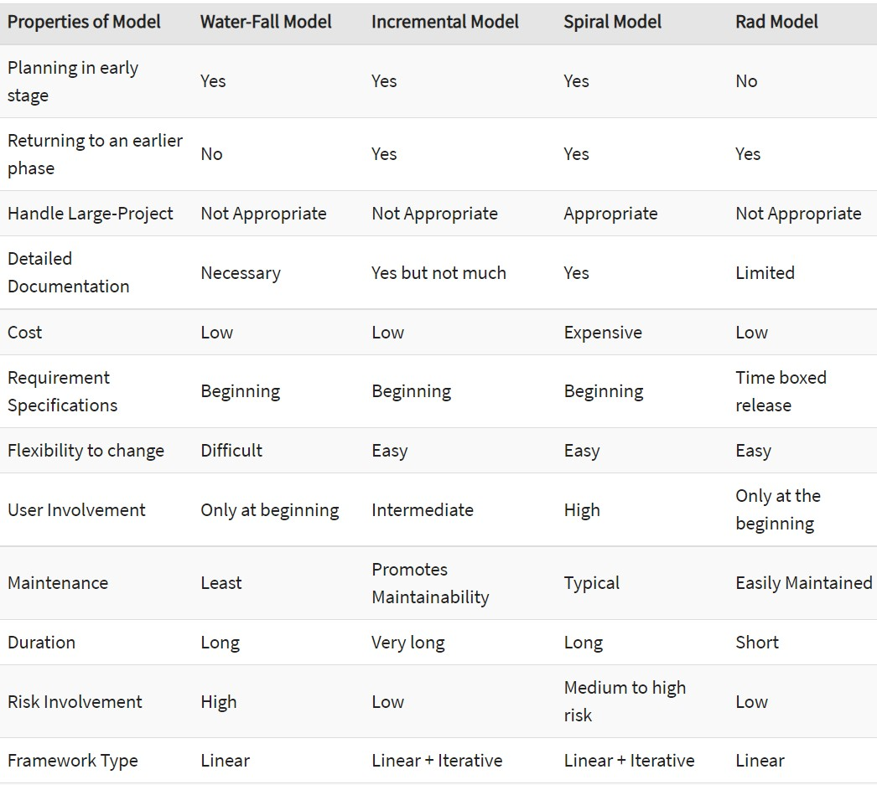

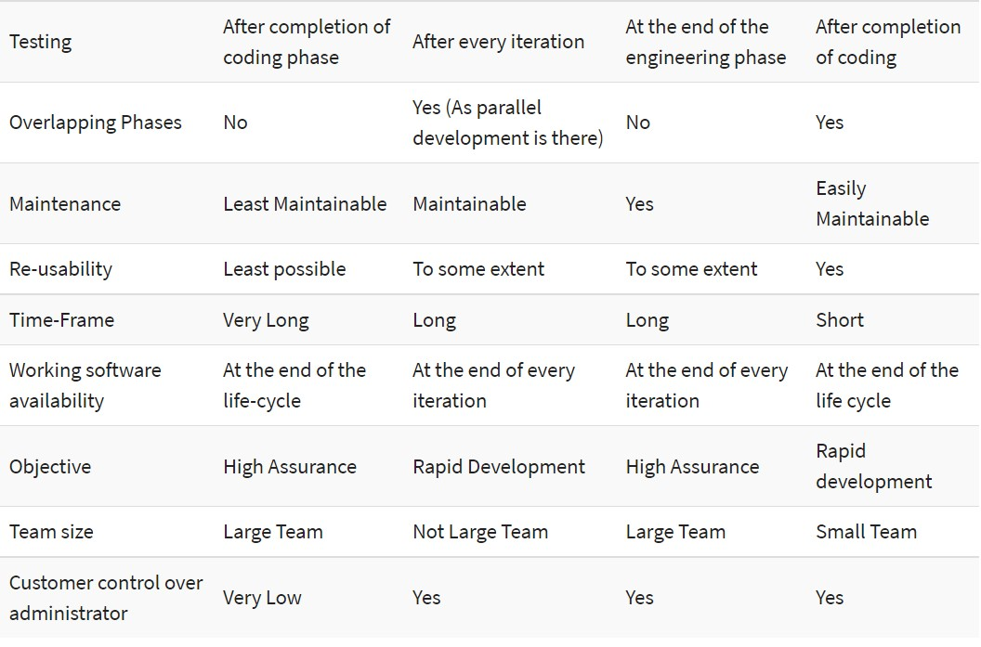

**DIAGRAM FOR SELECTED MODEL AND ITDESCRIPTION:**

* **Iterative Model:**
* Iterative and Incremental development is a combination of both iterative design or iterative method and incremental build model for development.
* "During software development, more than one iteration of the software development cycle may be in progress at the same time." This process may be described as an "evolutionary acquisition" or "incremental build" approach."
* In this incremental model, the whole requirement is divided into various builds.
* During each iteration, the development module goes through the requirements, design, implementation and testing phases.
* Each subsequent release of the module adds function to the previous release.
* The process continues till the complete system is ready as per the requirement.
* The key to a successful use of an iterative software development lifecycle is rigorous validation of requirements, and verification & testing of each version of the software against those requirements within each cycle of the model.
* **When to use the Iterative Model?**
* When requirements are defined clearly and easy to understand.
* When the software application is large.
* When there is a requirement of changes in future
* repeated and extended to verify each version of the software.
* **Iterative Model - Application**
* Requirements of the complete system are clearly defined and understood.
* Major requirements must be defined; however, some functionalities or requested enhancements may evolve with time.
* There is a time to the market constraint.
* A new technology is being used and is being learnt by the development team while working on the project.
* Resources with needed skill sets are not available and are planned to be used on contract basis for specific iterations.
* There are some high-risk features and goals which may change in the future.
* **Diagram Of Iterative Model:**

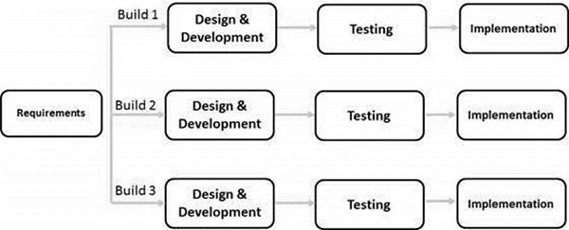

* **The various phases of Iterative model are as follows:**

**1. Requirement gathering & analysis:** In this phase, requirements are gathered from customers and check by an analyst whether requirements will fulfil or not. Analyst checks that need will achieve within budget or not. After all of this, the software team skips to the next phase.

**2. Design:** In the design phase, team design the software by the different diagrams like Data Flow diagram, activity diagram, class diagram, state transition diagram, etc.

**3. Implementation:** In the implementation, requirements are written in the coding language and transformed into computer programmers which are called Software.

**4. Testing:** After completing the coding phase, software testing starts using different test methods. There are many test methods, but the most common are white box, black box, and grey box test methods.

**5. Deployment:** After completing all the phases, software is deployed to its work environment.

**6. Review:** In this phase, after the product deployment, review phase is performed to check the behavior and validity of the developed product. And if there are any error found then the process starts again from the requirement gathering.

**7. Maintenance:** In the maintenance phase, after deployment of the software in the working environment there may be some bugs, some errors or new updates are required. Maintenance involves debugging and new addition options.

* **Advantage (Pros) of Iterative Model:**

1. Testing and debugging during smaller iteration is easy.
2. A Parallel development can plan.
3. It is easily acceptable to ever-changing needs of the project.
4. Risks are identified and resolved during iteration.
5. Limited time spent on documentation and extra time on designing.

* **Disadvantage (Cons) of Iterative Model:**

1. It is not suitable for smaller projects.
2. More Resources may be required.
3. Design can be changed again and again because of imperfect requirements.
4. Requirement changes can cause over budget.
5. Project completion date not confirmed because of changing requirements.

* **JUSTIFICATION: THAT WHY YOU CHOOSE THIS MODEL ONLY:**
* Some working functionality can be developed and early in the software development life cycle (SDLC).
* It is easily adaptable to the ever-changing needs of the project as well as the client.
* It is best suited for agile organizations.
* It is more cost effective to change the scope or requirements in Iterative model.
* Parallel development can be planned.
* Testing and debugging during smaller iteration is easy.
* 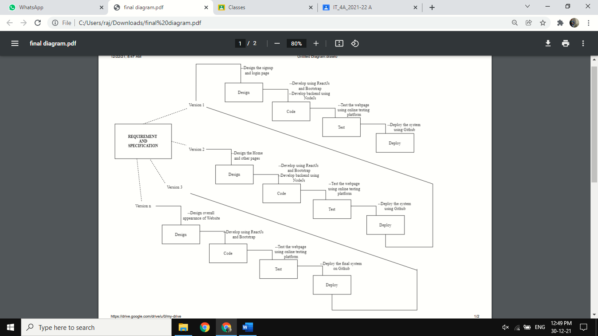**DIAGRAM OF MODEL ACCORDING TO YOUR DEFINATION:**

**Practical 3**

**AIM: - Study Software Requirement Engineering. Student should include SRS document for current semester project.**

* **SRS (Software Requirement Specification):**
* The production of the requirements stage of the software development process is Software Requirements Specifications (SRS) (also called a requirements document).
* This report lays a foundation for software engineering activities and is constructing when entire requirements are elicited and analyzed. SRS is a formal report, which acts as a representation of software that enables the customers to review whether it (SRS) is according to their requirements.
* Also, it comprises user requirements for a system as well as detailed specifications of the system requirements.
* The SRS is a specification for a specific software product, program, or set of applications that perform particular functions in a specific environment. It serves several goals depending on who is writing it.
* First, the SRS could be written by the client of a system. Second, the SRS could be written by a developer of the system.
* The two methods create entirely various situations and establish different purposes for the document altogether. The first case, SRS, is used to define the needs and expectation of the users. The second case, SRS, is written for various purposes and serves as a contract document between customer and developer.

# **SRS should address:**

The basic issues that the SRS shall address are the following:

a) Functionality. What is the software supposed to do?

b) External interfaces. How does the software interact with people, the system ‘s hardware, other hardware, and other software?

c) Performance. What is the speed, availability, response time, recovery time of various software functions, etc.?

d) Attributes. What is the portability, correctness, maintainability, security, etc. considerations?  
e) Design constraints imposed on an implementation. Are there any required standards in effect, implementation language, policies for database integrity, resource limits, operating environment(s)

* **Name of System:**
* HOME SERVICE PROVIDER.
* **Assumptions:**
* Users will directly be able to see our website & if they book any service at that time it will ask for login requirements or sign-up page.
* **Requirement 1: Register**

First the user will have to register/sign up. There are two different types of users.

* The head of company: The manager have to provide details about the name of company, address, phone number, email id, customers review about their work.
* Regular person: The user has to provide details about his/her name of address, phone number, email id.
* **Req1.1: Sign up**
* Input: Detail about the user as mentioned in the description.
* Output: Confirmation of registration status and a membership number and password/OTP will be generated and mailed to the user.
* Processing: All details will be checked and if any error is found then an error message is displayed else a membership number and password will be generated.
* **Req 1.2: Login**
* Input: Enter the membership number and password/OTP which is provided by company.
* Output: User will be able to use the features of software.
* **Requirement 2: How User will be able to get services.**
* **Req 2.1: Required services details**
* Description: List of different types of services available at that time will be generated.
* **Req 2.2: Search**
* Input: Enter the type of service which you want.
* Output: List of all related services with the company name and ratings will be generated.
* **Requirement 3: Manage workload by admin**
* **Req 3.1 Update details of the services: -**
* **Req 3.1.1 Add Company**
* Input: Enter the details of the services which you want such as name of services, name of company, opening date, quality.
* Output: Confirmation.
* **Req 3.1.2 Remove Company**
* Input: Enter the name of the company and quality of company.
* Output: Update the list of the services available by company
* **Requirement 4: Payment**
* **Req 4.1: Payment Gateway:**
* Input: Card Details, Paytm Wallet.
* Output: User receives the message of debited amount and booking confirmation.
* **Requirement 5: Help me...?**
* Input: The customer will ask the admin, or company for available services
* Output: Admin, users will find the available company and provide the link to the customer.
* **Requirement 6: Security**
* Passwords and value information is saved in database after hashing and AES encrypted, Admin has a separate login where he can add and modify user data if needed.
* **Requirement 7: Easy to use**
* User Friendly.
* **Requirement 8: Reliability**
* FAQ’s
* **Requirement 10: Portability**
* Website can be accessed on any device having any operating system.

**Practical 4**

**AIM:-** **Develop Software project management planning (SPMP) for the specified module.**

**Theory:**

* Once project designing is complete, project managers document their plans during a software package Project Management set up (SPMP) document. The SPMP document ought to discuss an inventory of various things that are mentioned below.
* This list will be used as a doable organization of the SPMP document. Organization of the software package Project Management set up (SPMP) document.
* **Introduction:-**
  + Objectives
  + Major Functions
  + Performance Issues
  + Management and Technical Constraints
* **Project Estimates:**
  + Historical Data Used
  + Estimation Techniques Used
  + Effort, Resource, Cost, and Project Duration Estimates
* **Schedule:**
  + Work Breakdown Structure
  + Task Network Representation
  + Gantt Chart Representation
  + PERT Chart Representation
* **Project Resources:**
  + People
  + Hardware and Software
  + Special Resources
* **Staff Organization:**
  + Team Structure
  + Management Reporting
* **Risk Management Plan:**
  + Risk Analysis
  + Risk Identification
  + Risk Estimation
  + Risk Abatement Procedures
* **Project Tracking and Control Plan**
* **Miscellaneous Plans:**
  + Process Tailoring
  + Quality Assurance Plan
  + Configuration Management Plan
  + Validation and Verification
  + System Testing Plan
  + Delivery, Installation, and Maintenance Plan

**What Is a Gantt Chart?**

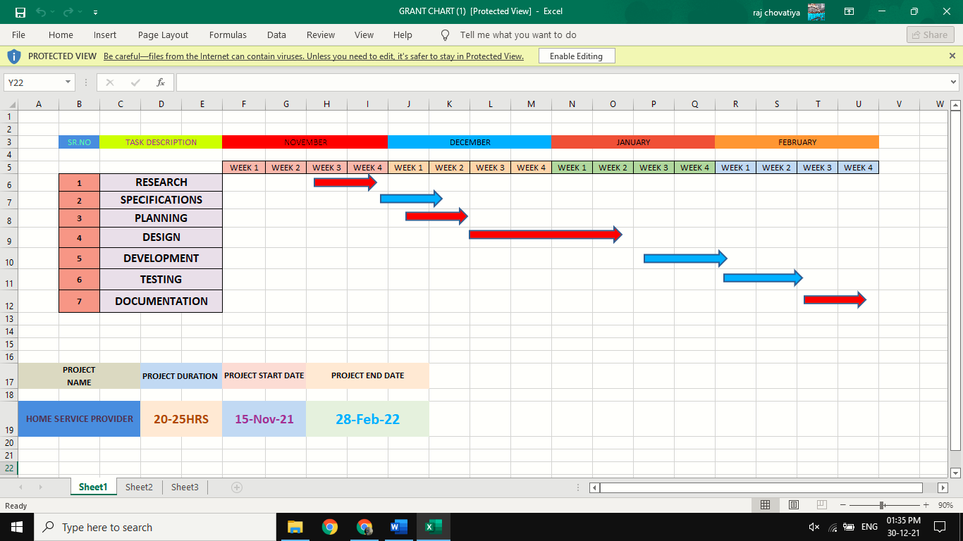**A Gantt chart is a bar chart that provides a visual view of project tasks scheduled over time.** A Gantt chart is used for project planning: it’s a useful way of showing what work is scheduled to be done on specific days. It helps project managers and team members view the start dates, end dates and milestones of a project schedule in one simple stacked bar chart.

**Practical 5**

**AIM:-** **Do Cost and Effort Estimation using different Software Cost Estimation models.**

**THEORY:**

**5.1 Cocomo model:**

Cocomo (Constructive Cost Model) is a regression model based on LOC, i.e. number of Lines of Code. It is a procedural cost estimate model for software projects and often used as a process of reliably predicting the various parameters associated with making a project such as size, effort, cost, time and quality.

* **The Modes**
* **Organic :**

2-50 KLOC, small, stable, little innovation

* **Semi-detached :**

50-300 KLOC, medium-sized, average abilities, medium time-constraints

* **Embedded :**

> 300 KLOC, large project team, complex, innovative, severe constraints

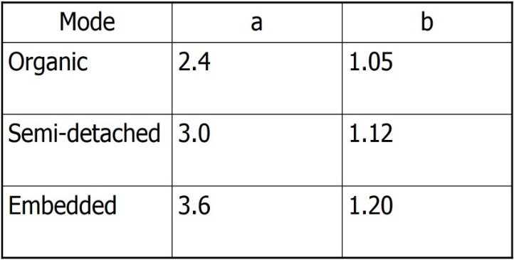**The constants cocomo model:**

**5.1.1 These are types of COCOMO model:**

1. **Basic COCOMO Model**
2. **Intermediate COCOMO Model**
3. **Detailed COCOMO Model**

**1.Basic cocomo model.**

**Equation of basic cocomo:**

𝑬 = 𝒂(𝑲𝑳𝑶𝑪)𝒃

Where,

* E = the Effort in staff months.
* a & b = coefficients to be determined.
* KLOC = thousands of lines of code.

**Effort:**

KLOC = 3, a = 2.4, b = 1.05

E=2.4

E=13.005 staff-month

**Development time(Project Duration):**

**TDEV=c**

Where,

* TDEV is time for development
* c and d are constants to be determined
* E is the effort

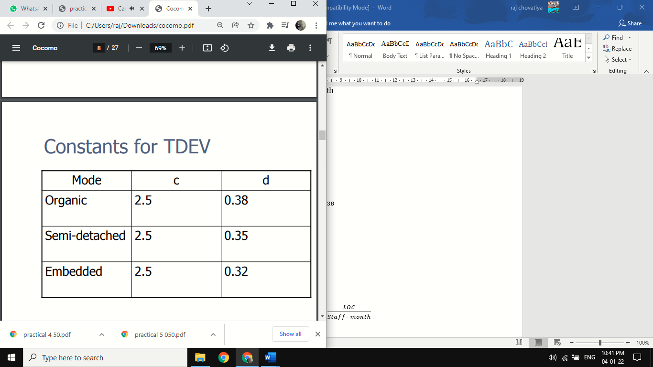Constants for TDEV,

**TDEV=c**

TDEV=2.5

TDEV=6.626 month

**Average Staff Size:**

**Staff size=**

Staff size=

Staff size=1.962 staff

**Productivity:**

**Productivity=**

Where,

* LOC = line of code
* E = effort

Productivity=

1. **Detailed cocomo model**

Detailed COCOMO incorporates all characteristics of the intermediate version with an assessment of the cost driver’s impact on each step of the software engineering process. The detailed model uses different effort multipliers for each cost driver attribute. In detailed cocomo, the whole software is divided into different modules and then we apply COCOMO in different modules to estimate effort and then sum the effort.

**The Six phases of detailed COCOMO are**:

• Planning and requirements

• System design

• Detailed design

• Module code and test

• Integration and test

• Cost Constructive model

The effort is calculated as a function of program size and a set of cost drivers are given according to each phase of the software lifecycle.

**Practical 6**

**AIM: -** Prepare System Analysis and System Design of identified Requirement specification using structure design as DFD with data dictionary and Structure chart for the specific module.

**THEORY:**

**DFD:** The objective of a DFD is to show the scope and boundaries of a system as a whole. It may be used as a communication tool between a system analyst and any person who plays a part in the order that acts as a starting point for redesigning a system. The DFD is also called as a data flow graph or bubble chart.

**DFD_Diagram:** 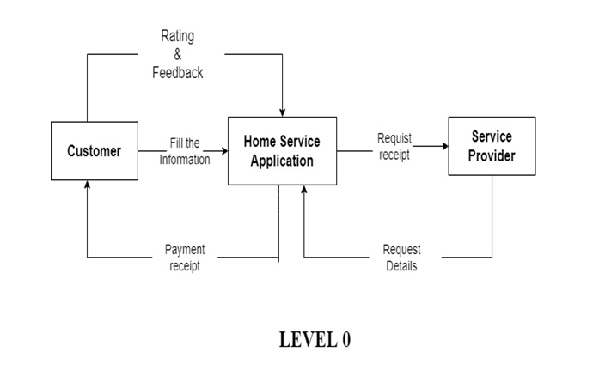

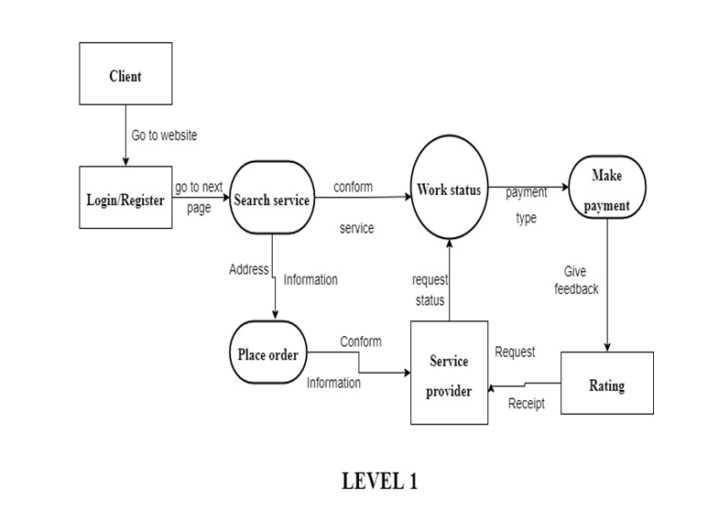

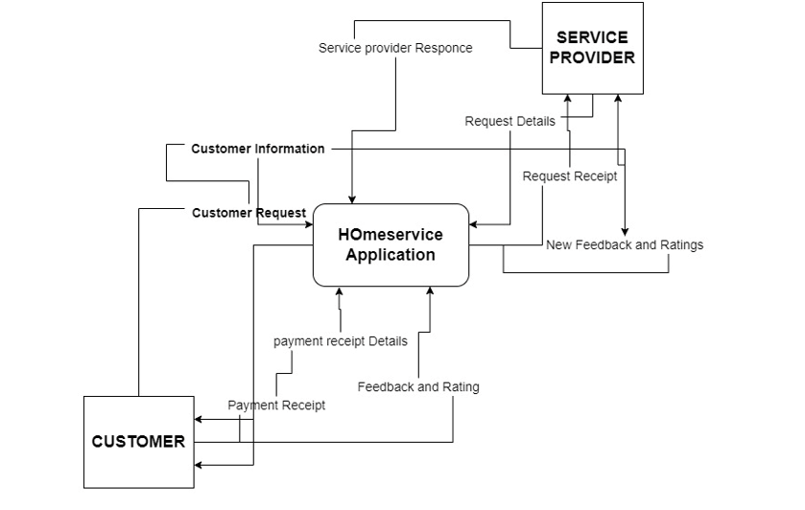

**LEVEL 2**

**DATA DICTIONARY:-**

* **Login Form:-**

|  |  |  |  |
| --- | --- | --- | --- |
| **Field name** | **Data type** | **Size** | **Constrain** |
| Username | Varchar | 50 | Not null |
| Password | Varchar | 50 | Not null |

* **Sign-up Form:-**

|  |  |  |  |
| --- | --- | --- | --- |
| **Field name** | **Data type** | **Size** | **Constrains** |
| Username | Varchar2 | - | Primary key |
| Email | Varchar2 | 255 | Not null |
| Password | Varchar2 | 255 | Not null |
| Confirm Password | Varchar2 | 255 | Not null |

* **Contact-Us:-**

|  |  |  |  |
| --- | --- | --- | --- |
| **Field name** | **Data type** | **Size** | **Constrains** |
| Name | Varchar2 | - | Primary key |
| Phone | Numeric | 255 | Not null |
| Email | Varchar2 | 255 | Primary key |
| Website | Varchar2 | 15 | Not null |
| Subject | Varchar2 | 255 | Not null |
| Your Message | Varchar2 | 255 | Not null |

**Practical 7**

**AIM:** Designing the module using Object Oriented approach including Use case Diagram with scenarios, Class Diagram and State Diagram, Collaboration Diagram, Sequence Diagram and Activity Diagram.

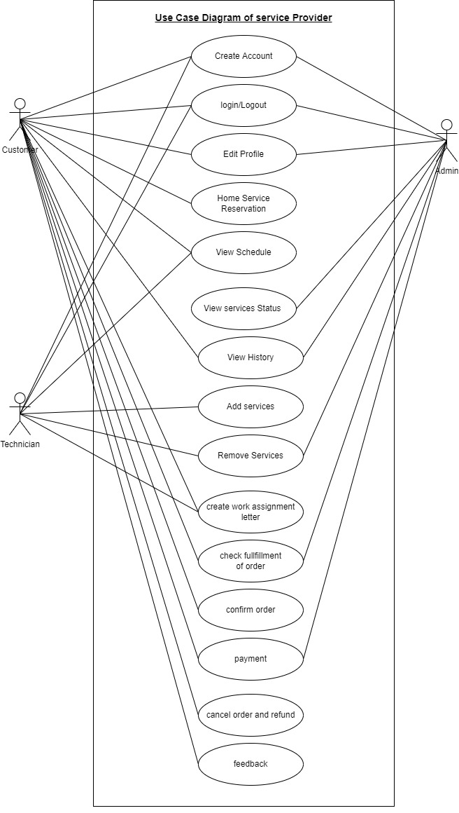**THEORY:**

**1.Use Case**

**Diagram**

**2. Class Diagram**

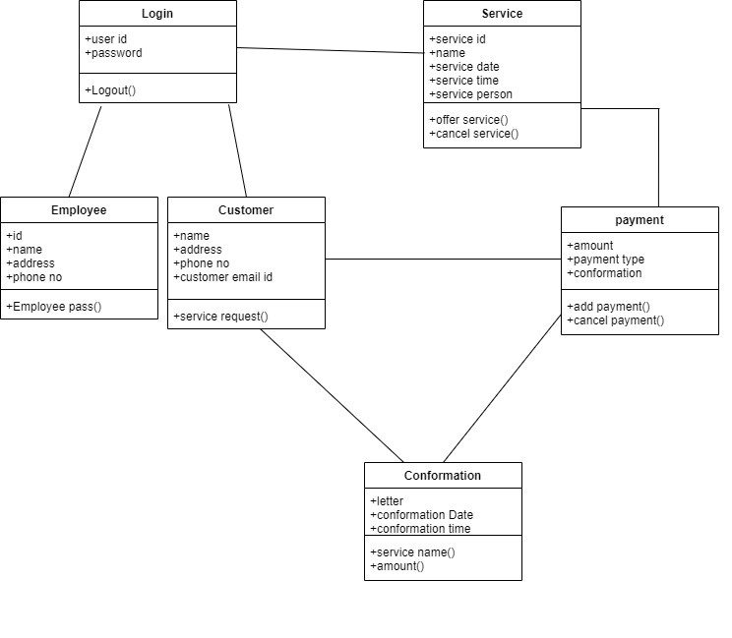

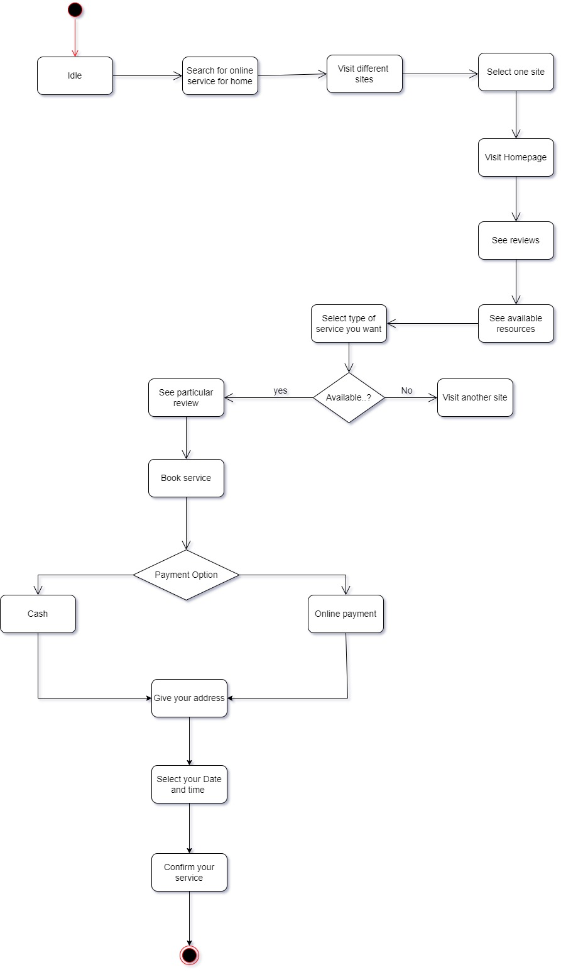**3. State Diagram**

**4.Activity Diagram**

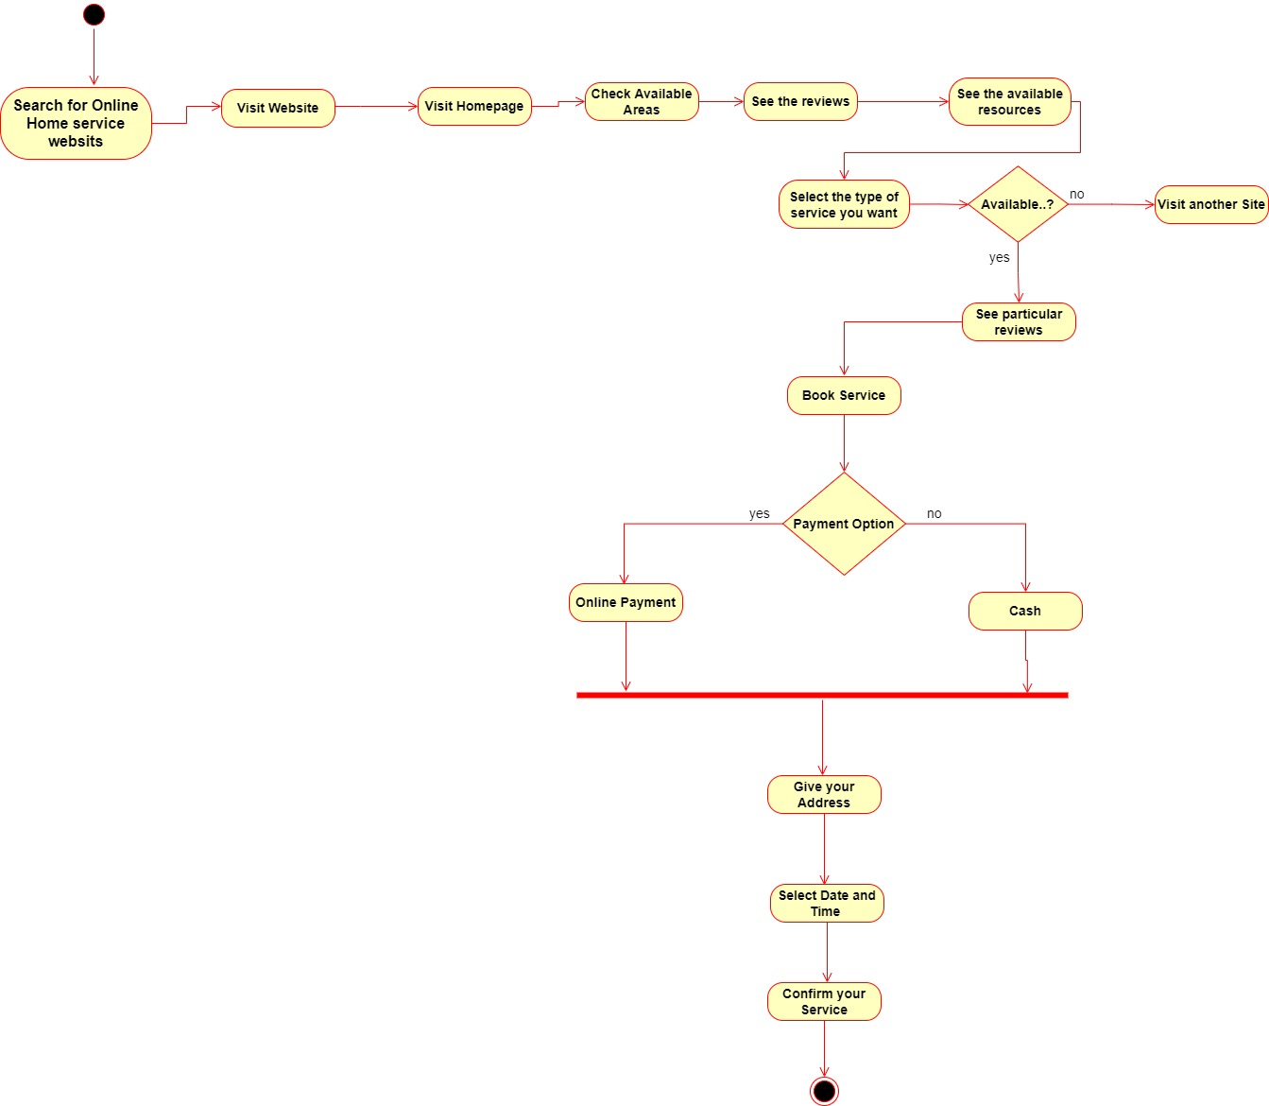

**5.Sequencec Diagram**

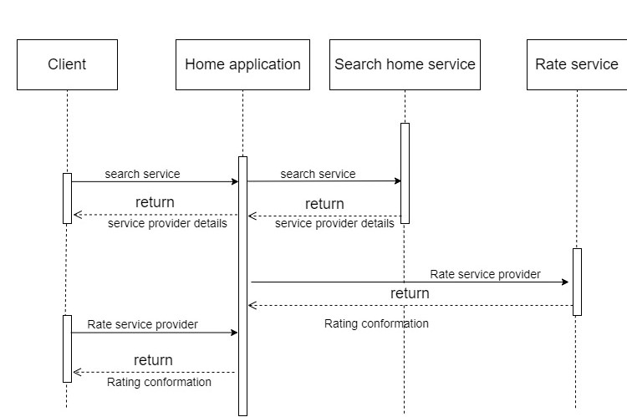

**Practical 8**

**AIM:** Defining Coding Standards and walk through.

**THEORY:**

* **Coding Standards:**

• Different modules specified in the design document are coded in the Coding phase according to the module specification. The main goal of the coding phase is to code from the design document prepared after the design phase through a high-level language and then to unit test this code.

• Good software development organizations want their programmers to maintain to some well- defined and standard style of coding called coding standards. They usually make their own coding standards and guidelines depending on what suits their organization best and based on the types of software they develop. It is very important for the programmers to maintain the coding standards otherwise the code will be rejected during code review.

* **Purpose of having coding standards:**

• A coding standard gives a uniform appearance to the codes written by different engineers.

• It improves readability, and maintainability of the code and it reduces complexity also.

• It helps in code reuse and helps to detect error easily.

• It promotes sound programming practices and increases efficiency of the programmers.

* **Some of the coding standard**s:

**1. Limited use of global:**

These rules talk about which types of data that can be declared global and the data that can’t be.

**2. Standard headers for different modules:**

For better understanding and maintenance of the code, the header of different modules should follow some standard format and information.

**The header format must contain below things that is being used in various companies:**

• Name of the module

• Date of module creation

• Author of the module

• Modification history

• Synopsis of the module about what the module does

• Different functions supported in the module along with their input output parameters

• Global variables accessed or modified by the module

**3. Naming conventions for local variables, global variables, constants and functions:**

Some of the naming conventions are given below:

• Meaningful and understandable variables name helps anyone to understand the reason of using it.

• Local variables should be named using camel case lettering starting with small letter (e.g., local Data) whereas Global variables names should start with a capital letter (e.g., Global Data). Constant names should be formed using capital letters only (e.g., CONSDATA).

• It is better to avoid the use of digits in variable names.

• The names of the function should be written in camel case starting with small letters.

• The name of the function must describe the reason of using the function clearly and briefly.

**4.Indentation:**

Proper indentation is very important to increase the readability of the code. For making the code readable, programmers should use White spaces properly.

Some of the spacing conventions are given below:

• There must be a space after giving a comma between two function arguments.

• Each nested block should be properly indented and spaced.

• Proper Indentation should be there at the beginning and at the end of each block in the program.

• All braces should start from a new line and the code following the end of braces also start from a new line.

**5. Error return values and exception handling conventions:**

All functions that encountering an error condition should either return a 0 or 1 for simplifying the debugging. On the other hand, Coding guidelines give some general suggestions regarding the coding style that to be followed for the betterment of understandability and readability of the code.

**6.Avoid using a coding style that is too difficult to understand:**

Code should be easily understandable. The complex code makes maintenance and debugging difficult and expensive.

**7.Avoid using an identifier for multiple purposes:**

Each variable should be given a descriptive and meaningful name indicating the reason behind using it. This is not possible if an identifier is used for multiple purposes and thus it can lead to confusion to the reader. Moreover, it leads to more difficulty during future enhancements.

**8.Code should be well documented:**

The code should be properly commented for understanding easily. Comments regarding the statements increase the understandability of the code.

**9.Length of functions should not be very large:**

Lengthy functions are very difficult to understand. That’s why functions should be small enough to carry out small work and lengthy functions should be broken into small ones for completing small tasks.

**10.Try not to use GOTO statement:**

GOTO statement makes the program unstructured, thus it reduces the understandability of the program and also debugging becomes difficult.

* **Advantages of Coding Guidelines:**

• Coding guidelines increase the efficiency of the software and reduces the development time.

• Coding guidelines help in detecting errors in the early phases, so it helps to reduce the extra cost incurred by the software project.

• If coding guidelines are maintained properly, then the software code increases readability and understandability thus it reduces the complexity of the code.

• It reduces the hidden cost for developing the software.

**Practical 9**

**AIM:** Write the testcases for the identified module.

**THEORY:**

**Home Page:-**

**Code:-**

<!DOCTYPE html>

<html lang="en">

<head>

    <meta charset="UTF-8">

    <meta http-equiv="X-UA-Compatible" content="IE=edge">

    <meta name="viewport" content="width=device-width, initial-scale=1.0">

    <title>HOME SERVICE PROVIDER</title>

    <link rel="stylesheet" type="text/css" href="style.css">

    <link href="https://unpkg.com/tailwindcss@^2/dist/tailwind.min.css" rel="stylesheet">

    <link href="https://fonts.googleapis.com/css2?family=Mochiy+Pop+P+One&display=swap" rel="stylesheet">

    <link rel="stylesheet" href="https://cdnjs.cloudflare.com/ajax/libs/animate.css/4.1.1/animate.min.css"/>

</head>

<body>

    <header>

        <nav>

            <div class="logo"> <h1 class="animate__animated animate__bounce animate__infinite infinite"> Home Service </h1></div>

            <div class="menu">

                <a href="home.html">Home</a>

                <a href="aboutus.html">About-Us</a>

                <a href="services.html">Services</a>

                <a href="contact-us.html">Contact</a>

            </div>

        </nav>

        <br>

        <br>

        <br>

        <br>

            <main>

                <section>

                    <h3>Welcome to our page..Here we provide best service with reasonable price..!</h3>

                    <h1>Here we provide services like <span class="change_content"></span> directly at home</h1>

                    <p>"We provide totally gauranteed services"</p>

                    <a href="login.html" class="btnone">Already a Customer.? Login Here</a>

                    <a href="signup.html" class="btntwo">Signup Here</a>

                </section>

            </main>

    </header>

 <br>

 <br>

 <section class="text-gray-600 body-font">

    <div class="container px-5 py-24 mx-auto">

      <div class="flex flex-col text-center w-full mb-20">

        <h1 class="text-2xl font-medium title-font mb-4 text-gray-900 tracking-widest">OUR TEAM</h1>

        <p class="lg:w-2/3 mx-auto leading-relaxed text-base"> Best Home Appliances Repair Service Centre In Vadodara: Our technicians go through rigorous training programs before they step out and start working.</p>

      </div>

      <div class="flex flex-wrap -m-4">

        <div class="p-4 lg:w-1/2">

          <div class="h-full flex sm:flex-row flex-col items-center sm:justify-start justify-center text-center sm:text-left">

            <img alt="team" class="flex-shrink-0 rounded-lg w-48 h-48 object-cover object-center sm:mb-0 mb-4" src="jayu1.jpg">

            <div class="flex-grow sm:pl-8">

              <h2 class="title-font font-medium text-lg text-gray-900">JAYNESH MODI</h2>

              <h3 class="text-gray-500 mb-3">IT-STUDENT</h3>

              <p class="mb-4">Currently Studing at Parul University,Course=B.tech in IT.</p>

              <span class="inline-flex">

                <a class="text-gray-500">

                  <svg fill="none" stroke="currentColor" stroke-linecap="round" stroke-linejoin="round" stroke-width="2" class="w-5 h-5" viewBox="0 0 24 24">

                    <path d="M18 2h-3a5 5 0 00-5 5v3H7v4h3v8h4v-8h3l1-4h-4V7a1 1 0 011-1h3z"></path>

                  </svg>

                </a>

                <a class="ml-2 text-gray-500">

                  <svg fill="none" stroke="currentColor" stroke-linecap="round" stroke-linejoin="round" stroke-width="2" class="w-5 h-5" viewBox="0 0 24 24">

                    <path d="M23 3a10.9 10.9 0 01-3.14 1.53 4.48 4.48 0 00-7.86 3v1A10.66 10.66 0 013 4s-4 9 5 13a11.64 11.64 0 01-7 2c9 5 20 0 20-11.5a4.5 4.5 0 00-.08-.83A7.72 7.72 0 0023 3z"></path>

                  </svg>

                </a>

                <a class="ml-2 text-gray-500">

                  <svg fill="none" stroke="currentColor" stroke-linecap="round" stroke-linejoin="round" stroke-width="2" class="w-5 h-5" viewBox="0 0 24 24">

                    <path d="M21 11.5a8.38 8.38 0 01-.9 3.8 8.5 8.5 0 01-7.6 4.7 8.38 8.38 0 01-3.8-.9L3 21l1.9-5.7a8.38 8.38 0 01-.9-3.8 8.5 8.5 0 014.7-7.6 8.38 8.38 0 013.8-.9h.5a8.48 8.48 0 018 8v.5z"></path>

                  </svg>

                </a>

              </span>

            </div>

          </div>

        </div>

        <div class="p-4 lg:w-1/2">

          <div class="h-full flex sm:flex-row flex-col items-center sm:justify-start justify-center text-center sm:text-left">

            <img alt="team" class="flex-shrink-0 rounded-lg w-48 h-48 object-cover object-center sm:mb-0 mb-4" src="hemil.jpeg">

            <div class="flex-grow sm:pl-8">

              <h2 class="title-font font-medium text-lg text-gray-900">HEMIL CHOVATIYA</h2>

              <h3 class="text-gray-500 mb-3">IT-STUDENT</h3>

              <p class="mb-4">Currently Studing at Parul University,Course=B.tech in IT.</p>

              <span class="inline-flex">

                <a class="text-gray-500">

                  <svg fill="none" stroke="currentColor" stroke-linecap="round" stroke-linejoin="round" stroke-width="2" class="w-5 h-5" viewBox="0 0 24 24">

                    <path d="M18 2h-3a5 5 0 00-5 5v3H7v4h3v8h4v-8h3l1-4h-4V7a1 1 0 011-1h3z"></path>

                  </svg>

                </a>

                <a class="ml-2 text-gray-500">

                  <svg fill="none" stroke="currentColor" stroke-linecap="round" stroke-linejoin="round" stroke-width="2" class="w-5 h-5" viewBox="0 0 24 24">

                    <path d="M23 3a10.9 10.9 0 01-3.14 1.53 4.48 4.48 0 00-7.86 3v1A10.66 10.66 0 013 4s-4 9 5 13a11.64 11.64 0 01-7 2c9 5 20 0 20-11.5a4.5 4.5 0 00-.08-.83A7.72 7.72 0 0023 3z"></path>

                  </svg>

                </a>

                <a class="ml-2 text-gray-500">

                  <svg fill="none" stroke="currentColor" stroke-linecap="round" stroke-linejoin="round" stroke-width="2" class="w-5 h-5" viewBox="0 0 24 24">

                    <path d="M21 11.5a8.38 8.38 0 01-.9 3.8 8.5 8.5 0 01-7.6 4.7 8.38 8.38 0 01-3.8-.9L3 21l1.9-5.7a8.38 8.38 0 01-.9-3.8 8.5 8.5 0 014.7-7.6 8.38 8.38 0 013.8-.9h.5a8.48 8.48 0 018 8v.5z"></path>

                  </svg>

                </a>

              </span>

            </div>

          </div>

        </div>

        <div class="p-4 lg:w-1/2">

          <div class="h-full flex sm:flex-row flex-col items-center sm:justify-start justify-center text-center sm:text-left">

            <img alt="team" class="flex-shrink-0 rounded-lg w-48 h-48 object-cover object-center sm:mb-0 mb-4" src="jay.jpg">

            <div class="flex-grow sm:pl-8">

              <h2 class="title-font font-medium text-lg text-gray-900">JAY KHANPARA</h2>

              <h3 class="text-gray-500 mb-3">IT-STUDENT</h3>

              <p class="mb-4">Currently Studing at Parul University,Course=B.tech in IT.</p>

              <span class="inline-flex">

                <a class="text-gray-500">

                  <svg fill="none" stroke="currentColor" stroke-linecap="round" stroke-linejoin="round" stroke-width="2" class="w-5 h-5" viewBox="0 0 24 24">

                    <path d="M18 2h-3a5 5 0 00-5 5v3H7v4h3v8h4v-8h3l1-4h-4V7a1 1 0 011-1h3z"></path>

                  </svg>

                </a>

                <a class="ml-2 text-gray-500">

                  <svg fill="none" stroke="currentColor" stroke-linecap="round" stroke-linejoin="round" stroke-width="2" class="w-5 h-5" viewBox="0 0 24 24">

                    <path d="M23 3a10.9 10.9 0 01-3.14 1.53 4.48 4.48 0 00-7.86 3v1A10.66 10.66 0 013 4s-4 9 5 13a11.64 11.64 0 01-7 2c9 5 20 0 20-11.5a4.5 4.5 0 00-.08-.83A7.72 7.72 0 0023 3z"></path>

                  </svg>

                </a>

                <a class="ml-2 text-gray-500">

                  <svg fill="none" stroke="currentColor" stroke-linecap="round" stroke-linejoin="round" stroke-width="2" class="w-5 h-5" viewBox="0 0 24 24">

                    <path d="M21 11.5a8.38 8.38 0 01-.9 3.8 8.5 8.5 0 01-7.6 4.7 8.38 8.38 0 01-3.8-.9L3 21l1.9-5.7a8.38 8.38 0 01-.9-3.8 8.5 8.5 0 014.7-7.6 8.38 8.38 0 013.8-.9h.5a8.48 8.48 0 018 8v.5z"></path>

                  </svg>

                </a>

              </span>

            </div>

          </div>

        </div>

        <div class="p-4 lg:w-1/2">

          <div class="h-full flex sm:flex-row flex-col items-center sm:justify-start justify-center text-center sm:text-left">

            <img alt="team" class="flex-shrink-0 rounded-lg w-48 h-48 object-cover object-center sm:mb-0 mb-4" src="romit.jpg">

            <div class="flex-grow sm:pl-8">

              <h2 class="title-font font-medium text-lg text-gray-900">ROMIT</h2>

              <h3 class="text-gray-500 mb-3">IT-STUDENT</h3>

              <p class="mb-4">Currently Studing at Parul University,Course=B.tech in IT.</p>

              <span class="inline-flex">

                <a class="text-gray-500">

                  <svg fill="none" stroke="currentColor" stroke-linecap="round" stroke-linejoin="round" stroke-width="2" class="w-5 h-5" viewBox="0 0 24 24">

                    <path d="M18 2h-3a5 5 0 00-5 5v3H7v4h3v8h4v-8h3l1-4h-4V7a1 1 0 011-1h3z"></path>

                  </svg>

                </a>

                <a class="ml-2 text-gray-500">

                  <svg fill="none" stroke="currentColor" stroke-linecap="round" stroke-linejoin="round" stroke-width="2" class="w-5 h-5" viewBox="0 0 24 24">

                    <path d="M23 3a10.9 10.9 0 01-3.14 1.53 4.48 4.48 0 00-7.86 3v1A10.66 10.66 0 013 4s-4 9 5 13a11.64 11.64 0 01-7 2c9 5 20 0 20-11.5a4.5 4.5 0 00-.08-.83A7.72 7.72 0 0023 3z"></path>

                  </svg>

                </a>

                <a class="ml-2 text-gray-500">

                  <svg fill="none" stroke="currentColor" stroke-linecap="round" stroke-linejoin="round" stroke-width="2" class="w-5 h-5" viewBox="0 0 24 24">

                    <path d="M21 11.5a8.38 8.38 0 01-.9 3.8 8.5 8.5 0 01-7.6 4.7 8.38 8.38 0 01-3.8-.9L3 21l1.9-5.7a8.38 8.38 0 01-.9-3.8 8.5 8.5 0 014.7-7.6 8.38 8.38 0 013.8-.9h.5a8.48 8.48 0 018 8v.5z"></path>

                  </svg>

                </a>

              </span>

            </div>

          </div>

        </div>

      </div>

    </div>

  </section>

  <section class="text-gray-600 body-font relative">

    <div class="container px-5 py-24 mx-auto">

      <div class="flex flex-col text-center w-full mb-12">

        <h1 class="sm:text-3xl text-2xl font-medium title-font mb-4 text-gray-900">Contact Us</h1>

        <p class="lg:w-2/3 mx-auto leading-relaxed text-base">For any type of query or doubt submit the below given form with doubt or Mail Us on our Given Mail'ID..!!</p>

      </div>

      <div class="lg:w-1/2 md:w-2/3 mx-auto">

        <div class="flex flex-wrap -m-2">

          <div class="p-2 w-1/2">

            <div class="relative">

              <label for="name" class="leading-7 text-sm text-gray-600">Name</label>

              <input type="text" id="name" name="name" class="w-full bg-gray-100 bg-opacity-50 rounded border border-gray-300 focus:border-red-500 focus:bg-white focus:ring-2 focus:ring-red-200 text-base outline-none text-gray-700 py-1 px-3 leading-8 transition-colors duration-200 ease-in-out">

            </div>

          </div>

          <div class="p-2 w-1/2">

            <div class="relative">

              <label for="email" class="leading-7 text-sm text-gray-600">Email</label>

              <input type="email" id="email" name="email" class="w-full bg-gray-100 bg-opacity-50 rounded border border-gray-300 focus:border-red-500 focus:bg-white focus:ring-2 focus:ring-red-200 text-base outline-none text-gray-700 py-1 px-3 leading-8 transition-colors duration-200 ease-in-out">

            </div>

          </div>

          <div class="p-2 w-full">

            <div class="relative">

              <label for="message" class="leading-7 text-sm text-gray-600">Message</label>

              <textarea id="message" name="message" class="w-full bg-gray-100 bg-opacity-50 rounded border border-gray-300 focus:border-red-500 focus:bg-white focus:ring-2 focus:ring-red-200 h-32 text-base outline-none text-gray-700 py-1 px-3 resize-none leading-6 transition-colors duration-200 ease-in-out"></textarea>

            </div>

          </div>

          <div class="p-2 w-full">

            <button class="flex mx-auto text-white bg-red-500 border-0 py-2 px-8 focus:outline-none hover:bg-red-600 rounded text-lg">Submit</button>

          </div>

          <div class="p-2 w-full pt-8 mt-8 border-t border-gray-200 text-center">

            <a class="text-red-500">jaineshmodi76@gmail.com</a>

            <p class="leading-normal my-5">412,Parul University

              <br>Waghodia,Vadodara

            </p>

            <span class="inline-flex">

              <a class="text-gray-500">

                <svg fill="currentColor" stroke-linecap="round" stroke-linejoin="round" stroke-width="2" class="w-5 h-5" viewBox="0 0 24 24">

                  <path d="M18 2h-3a5 5 0 00-5 5v3H7v4h3v8h4v-8h3l1-4h-4V7a1 1 0 011-1h3z"></path>

                </svg>

              </a>

              <a class="ml-4 text-gray-500">

                <svg fill="currentColor" stroke-linecap="round" stroke-linejoin="round" stroke-width="2" class="w-5 h-5" viewBox="0 0 24 24">

                  <path d="M23 3a10.9 10.9 0 01-3.14 1.53 4.48 4.48 0 00-7.86 3v1A10.66 10.66 0 013 4s-4 9 5 13a11.64 11.64 0 01-7 2c9 5 20 0 20-11.5a4.5 4.5 0 00-.08-.83A7.72 7.72 0 0023 3z"></path>

                </svg>

              </a>

              <a class="ml-4 text-gray-500">

                <svg fill="none" stroke="currentColor" stroke-linecap="round" stroke-linejoin="round" stroke-width="2" class="w-5 h-5" viewBox="0 0 24 24">

                  <rect width="20" height="20" x="2" y="2" rx="5" ry="5"></rect>

                  <path d="M16 11.37A4 4 0 1112.63 8 4 4 0 0116 11.37zm1.5-4.87h.01"></path>

                </svg>

              </a>

              <a class="ml-4 text-gray-500">

                <svg fill="currentColor" stroke-linecap="round" stroke-linejoin="round" stroke-width="2" class="w-5 h-5" viewBox="0 0 24 24">

                  <path d="M21 11.5a8.38 8.38 0 01-.9 3.8 8.5 8.5 0 01-7.6 4.7 8.38 8.38 0 01-3.8-.9L3 21l1.9-5.7a8.38 8.38 0 01-.9-3.8 8.5 8.5 0 014.7-7.6 8.38 8.38 0 013.8-.9h.5a8.48 8.48 0 018 8v.5z"></path>

                </svg>

              </a>

            </span>

          </div>

        </div>

      </div>

    </div>

  </section>

  <footer class="text-gray-600 body-font">

    <div class="container px-5 py-8 mx-auto flex items-center sm:flex-row flex-col">

      <a class="flex title-font font-medium items-center md:justify-start justify-center text-gray-900">

        <svg xmlns="http://www.w3.org/2000/svg" fill="none" stroke="currentColor" stroke-linecap="round" stroke-linejoin="round" stroke-width="2" class="w-10 h-10 text-white p-2 bg-red-500 rounded-full" viewBox="0 0 24 24">

          <path d="M12 2L2 7l10 5 10-5-10-5zM2 17l10 5 10-5M2 12l10 5 10-5"></path>

        </svg>

        <span class="ml-3 text-xl">HOME SERVICE PROVIDER</span>

      </a>

      <p class="text-sm text-gray-500 sm:ml-4 sm:pl-4 sm:border-l-2 sm:border-gray-200 sm:py-2 sm:mt-0 mt-4">© 2022 — HOME SERVICE PROVIDER

        <a href="https://twitter.com/jayneshh10" class="text-gray-600 ml-1" rel="noopener noreferrer" target="_blank">@jayneshh10</a>

      </p>

      <span class="inline-flex sm:ml-auto sm:mt-0 mt-4 justify-center sm:justify-start">

        <a class="text-gray-500">

          <svg fill="currentColor" stroke-linecap="round" stroke-linejoin="round" stroke-width="2" class="w-5 h-5" viewBox="0 0 24 24">

            <path d="M18 2h-3a5 5 0 00-5 5v3H7v4h3v8h4v-8h3l1-4h-4V7a1 1 0 011-1h3z"></path>

          </svg>

        </a>

        <a class="ml-3 text-gray-500">

          <svg fill="currentColor" stroke-linecap="round" stroke-linejoin="round" stroke-width="2" class="w-5 h-5" viewBox="0 0 24 24">

            <path d="M23 3a10.9 10.9 0 01-3.14 1.53 4.48 4.48 0 00-7.86 3v1A10.66 10.66 0 013 4s-4 9 5 13a11.64 11.64 0 01-7 2c9 5 20 0 20-11.5a4.5 4.5 0 00-.08-.83A7.72 7.72 0 0023 3z"></path>

          </svg>

        </a>

        <a class="ml-3 text-gray-500">

          <svg fill="none" stroke="currentColor" stroke-linecap="round" stroke-linejoin="round" stroke-width="2" class="w-5 h-5" viewBox="0 0 24 24">

            <rect width="20" height="20" x="2" y="2" rx="5" ry="5"></rect>

            <path d="M16 11.37A4 4 0 1112.63 8 4 4 0 0116 11.37zm1.5-4.87h.01"></path>

          </svg>

        </a>

        <a class="ml-3 text-gray-500">

          <svg fill="currentColor" stroke="currentColor" stroke-linecap="round" stroke-linejoin="round" stroke-width="0" class="w-5 h-5" viewBox="0 0 24 24">

            <path stroke="none" d="M16 8a6 6 0 016 6v7h-4v-7a2 2 0 00-2-2 2 2 0 00-2 2v7h-4v-7a6 6 0 016-6zM2 9h4v12H2z"></path>

            <circle cx="4" cy="4" r="2" stroke="none"></circle>

          </svg>

        </a>

      </span>

    </div>

  </footer>

</body>

</html>

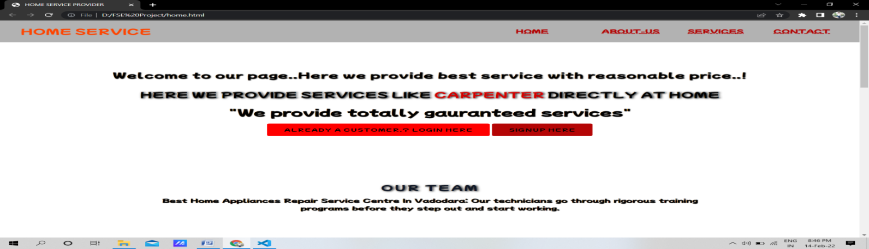**Output:-**

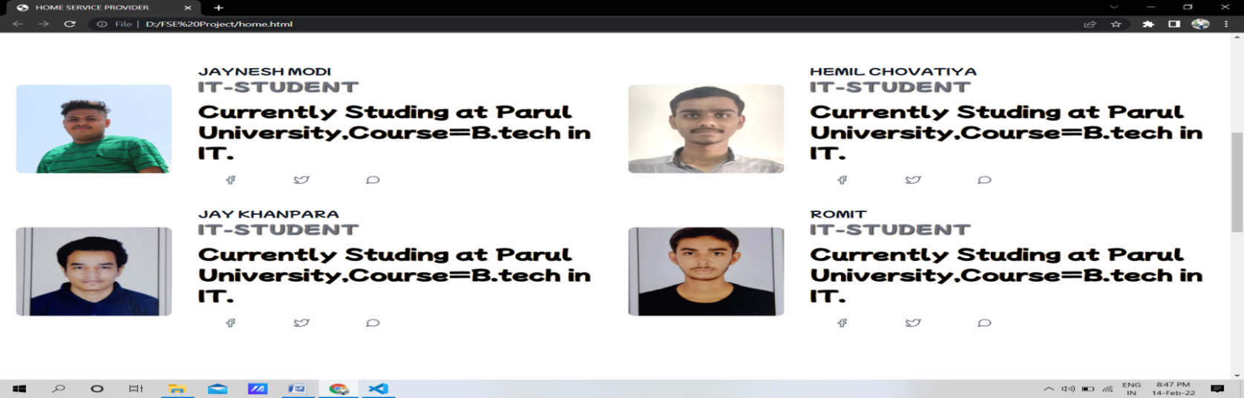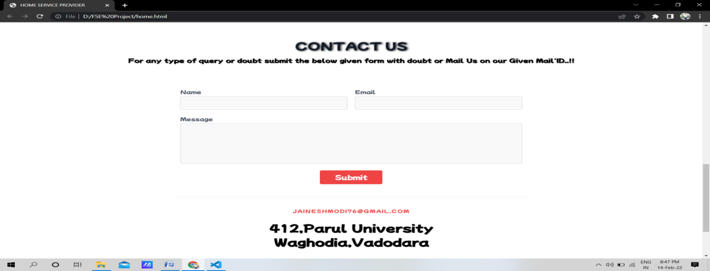

**Login Code:-**

<!DOCTYPE html>

<html>

<head>

    <title>Login </title>

    <link rel="stylesheet" type="text/css" href="stylelogin.css">

    <link href="https://fonts.googleapis.com/css2?family=Mochiy+Pop+P+One&display=swap" rel="stylesheet">

    <script src="https://kit.fontawesome.com/a81368914c.js"></script>

    <meta name="viewport" content="width=device-width, initial-scale=1">

</head>

<body>

    <div class="container">

        <div class="img">

            <img src="download.png" height="75%" width="30%">

        </div>

        <div class="login-content">

            <form action="index.html">

                <img src="logo2.jpg" height="30%" width="30%">

                <h2 class="title">Welcome</h2>

                <div class="input-div one">

                   <div class="i">

                        <i class="fas fa-user"></i>

                   </div>

                   <div class="div">

                        <h5>Username</h5>

                        <input type="text" class="input">

                   </div>

                </div>

                <div class="input-div pass">

                   <div class="i">

                        <i class="fas fa-lock"></i>

                   </div>

                   <div class="div">

                        <h5>Password</h5>

                        <input type="password" class="input">

                   </div>

                </div>

                <a href="#">Forgot Password?</a>

                <input type="submit" class="btn" value="Login">

            </form>

        </div>

    </div>

    <script type="text/javascript" src="main.js"></script>

</body>

</html>

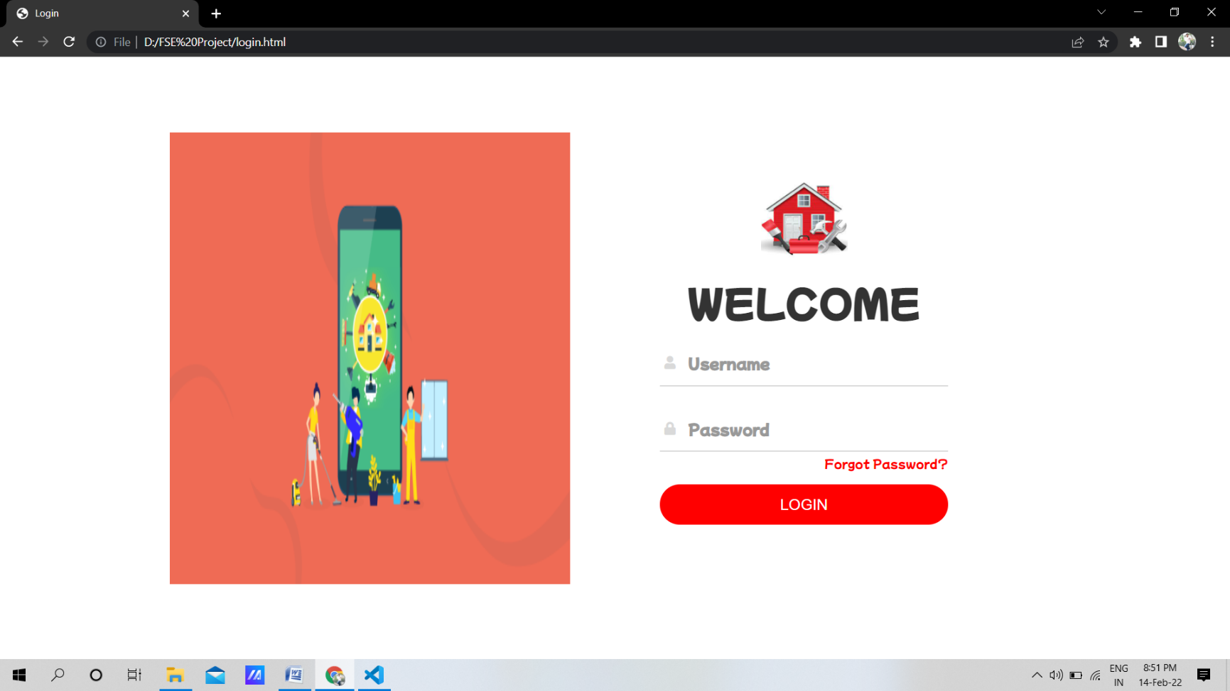**Output:-**

**Sign-Up Code:-**

<title>Sign Up</title>

<link href="https://fonts.googleapis.com/css2?family=Mochiy+Pop+P+One&display=swap" rel="stylesheet">

<link rel="stylesheet" type="text/css" href="signup.css">

<body>

<div class="container">

    <div class="header">

        <h2>Create Account</h2>

    </div>

    <form id="form" class="form">

        <div class="form-control">

            <label for="username">Username</label>

            <input type="text" placeholder="jayumodi24" id="username" />

            <i class="fas fa-check-circle"></i>

            <i class="fas fa-exclamation-circle"></i>

            <small>Error message</small>

        </div>

        <div class="form-control">

            <label for="username">Email</label>

            <input type="email" placeholder="jym@gmail.com" id="email" />

            <i class="fas fa-check-circle"></i>

            <i class="fas fa-exclamation-circle"></i>

            <small>Error message</small>

        </div>

        <div class="form-control">

            <label for="username">Password</label>

            <input type="password" placeholder="Enter Strong Password" id="password"/>

            <i class="fas fa-check-circle"></i>

            <i class="fas fa-exclamation-circle"></i>

            <small>Error message</small>

        </div>

        <div class="form-control">

            <label for="username">Confirm Password</label>

            <input type="password" placeholder="Re-enter Password" id="password2"/>

            <i class="fas fa-check-circle"></i>

            <i class="fas fa-exclamation-circle"></i>

            <small>Error message</small>

        </div>

        <button>Submit</button>

        <script type="text/javascript" src="signup.js"></script>

        <br>

        <br>

        <div style="display: flex; justify-content: center;">

            <style type="text/css">

              .googleButton {

                color: #4285f4;

                text-decoration: none;

                border: 1px solid #4285f4;

                border-radius: 4px;

                display: flex;

                overflow: hidden;

                align-items: center;

                margin-bottom: 20px;

                transition: 0.3s transform;

              }

              .googleButton:hover {

                  transform: scale3d(1.07, 1.07, 1);

              }

              .googleButton .icon {

                width: 40px;

                height: 40px;

                background-color: white;

                display: flex;

                align-items: center;

                justify-content: center;

              }

              .googleButton .text {

                height: 40px;

                padding: 0 20px;

                background-color: #4285f4;

                color: white;

                display: flex;

                align-items: center;

                justify-content: center;

              }

            </style>

            <a class="googleButton" href="https://accounts.google.com/o/saml2/initsso?idpid=C01if9sy4&spid=58763844501&forceauthn=false" title="Login with Google Account">

                  <span class="icon" style="">

                      <svg version="1.1" xmlns="http://www.w3.org/2000/svg" width="18px" height="18px" viewBox="0 0 48 48"><g><path fill="#EA4335" d="M24 9.5c3.54 0 6.71 1.22 9.21 3.6l6.85-6.85C35.9 2.38 30.47 0 24 0 14.62 0 6.51 5.38 2.56 13.22l7.98 6.19C12.43 13.72 17.74 9.5 24 9.5z"></path><path fill="#4285F4" d="M46.98 24.55c0-1.57-.15-3.09-.38-4.55H24v9.02h12.94c-.58 2.96-2.26 5.48-4.78 7.18l7.73 6c4.51-4.18 7.09-10.36 7.09-17.65z"></path><path fill="#FBBC05" d="M10.53 28.59c-.48-1.45-.76-2.99-.76-4.59s.27-3.14.76-4.59l-7.98-6.19C.92 16.46 0 20.12 0 24c0 3.88.92 7.54 2.56 10.78l7.97-6.19z"></path><path fill="#34A853" d="M24 48c6.48 0 11.93-2.13 15.89-5.81l-7.73-6c-2.15 1.45-4.92 2.3-8.16 2.3-6.26 0-11.57-4.22-13.47-9.91l-7.98 6.19C6.51 42.62 14.62 48 24 48z"></path><path fill="none" d="M0 0h48v48H0z"></path></g>

                            </svg>

                  </span>

                  <span class="text">Login with Google</span>

                  </a>

          </div>

    </form>

</div>

</body>

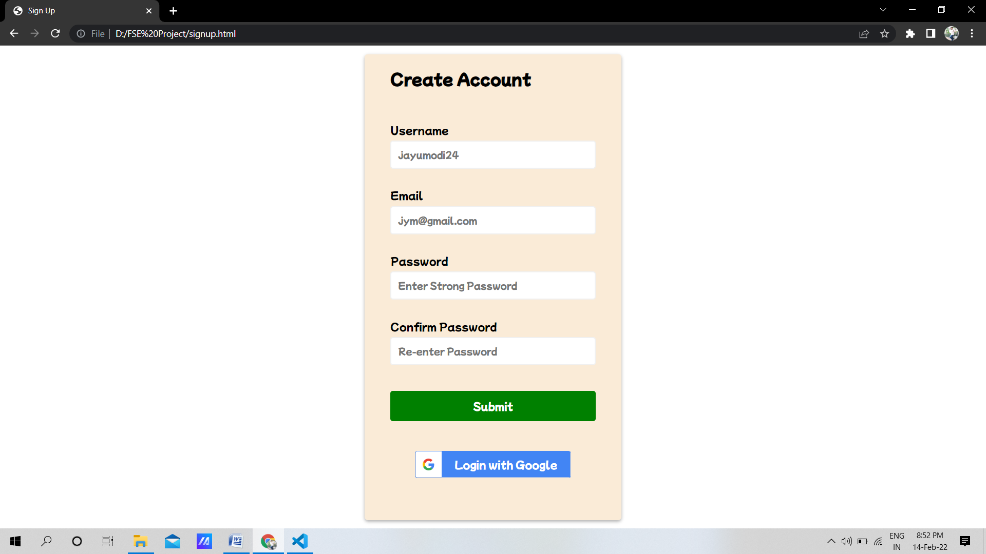**Output:-**

**Services:-**

<!DOCTYPE html>

<html lang="en" dir="ltr">

  <head>

    <meta charset="utf-8">

    <title>Our Services</title>

    <link rel="stylesheet" href="style1.css">

    <meta name="viewport" content="width=device-width, initial-scale=1">

    <link href="https://unpkg.com/tailwindcss@^2/dist/tailwind.min.css" rel="stylesheet">

    <link href="https://fonts.googleapis.com/css2?family=Mochiy+Pop+P+One&display=swap" rel="stylesheet">

    <link rel="stylesheet" href="https://use.fontawesome.com/releases/v5.7.2/css/all.css">

    <script src="https://kit.fontawesome.com/99721457ed.js" crossorigin="anonymous"></script>

    <link rel="stylesheet" href="https://cdnjs.cloudflare.com/ajax/libs/animate.css/4.1.1/animate.min.css"/>

  </head>

  <body>

    <nav>

      <div class="logo"> <h1 class="animate__animated animate__bounce animate__infinite infinite"> Home Service </h1></div>

      <div class="menu">

          <a href="home.html">Home</a>

          <a href="aboutus.html">About-Us</a>

          <a href="services.html">Services</a>

          <a href="contact-us.html">Contact</a>

      </div>

  </nav>

  <br>

     <div class="services-section">

      <div class="inner-width">

        <h1 class="section-title">Our Services</h1>

        <div class="border"></div>

        <div class="services-container">

          <div class="service-box">

            <div class="service-icon">

              <i class="fas fa-bolt"></i>

            </div>

            <div class="service-title"><a href="electrician.html">Electrician</a></div>

            <div class="service-desc">

              Our trained and qualified technicians get ongoing training to ensure to receive world-class servicing.

              Our certified and experienced professionals are well aware of multiple services under repair and render services that will last in the long run to save you money.

              For more details please click on "Electrician"..!

            </div>

          </div>

          <div class="service-box">

            <div class="service-icon">

              <i class="fas fa-wrench"></i>

            </div>

            <div class="service-title"><a href="plumbing.html">Plumbing</a></div>

            <div class="service-desc">

              Our trained and qualified technicians get ongoing training to ensure to receive world-class servicing.

              Our certified and experienced professionals are well aware of multiple services under repair and render services that will last in the long run to save you money.

              For more details please click on "Plumbing"..!

            </div>

          </div>

          <div class="service-box">

            <div class="service-icon">

              <i class="fas fa-car"></i>

            </div>

            <div class="service-title"><a href="Cardrivers.html">Car Drivers</a></div>

            <div class="service-desc">

              Our trained and qualified technicians get ongoing training to ensure to receive world-class servicing.

              Our certified and experienced professionals are well aware of multiple services under repair and render services that will last in the long run to save you money.

              For more details please click on "Car Drivers"..!

            </div>

          </div>

          <div class="service-box">

            <div class="service-icon">

              <i class="fas fa-fan"></i>

            </div>

            <div class="service-title"><a href="gardening.html">Gardening</a></div>

            <div class="service-desc">

              Our trained and qualified technicians get ongoing training to ensure to receive world-class servicing.

              Our certified and experienced professionals are well aware of multiple services under repair and render services that will last in the long run to save you money.

              For more details please click on "Gardening"..!

            </div>

          </div>

          <div class="service-box">

            <div class="service-icon">

              <i class="fas fa-tools"></i>

            </div>

            <div class="service-title"><a href="carpenter.html">Carpenter</a></div>

            <div class="service-desc">

              Our trained and qualified technicians get ongoing training to ensure to receive world-class servicing.

              Our certified and experienced professionals are well aware of multiple services under repair and render services that will last in the long run to save you money.

              For more details please click on "Carpenter"..!

            </div>

          </div>

          <div class="service-box">

            <div class="service-icon">

              <i class="fas fa-house-user"></i>

            </div>

            <div class="service-title"><a href="cleaninghouse.html">Cleaning House</a></div>

            <div class="service-desc">

              Our trained and qualified technicians get ongoing training to ensure to receive world-class servicing.

              Our certified and experienced professionals are well aware of multiple services under repair and render services that will last in the long run to save you money.

              For more details please click on "Cleaning House"..!

            </div>

          </div>

          <div class="service-box">

            <div class="service-icon">

              <i class="fas fa-hamburger"></i>

            </div>

            <div class="service-title"><a href="foodordering.html">Food Ordering</a></div>

            <div class="service-desc">

              Our trained and qualified technicians get ongoing training to ensure to receive world-class servicing.

              Our certified and experienced professionals are well aware of multiple services under repair and render services that will last in the long run to save you money.

              For more details please click on "Food Ordering"..!

            </div>

          </div>

          <div class="service-box">

            <div class="service-icon">

              <i class="fas fa-database"></i>

            </div>

            <div class="service-title"><a href="cook.html">Cook</a></div>

            <div class="service-desc">

              Our trained and qualified technicians get ongoing training to ensure to receive world-class servicing.

              Our certified and experienced professionals are well aware of multiple services under repair and render services that will last in the long run to save you money.

              For more details please click on "Cook"..!

            </div>

          </div>

          <div class="service-box">

            <div class="service-icon">

              <i class="fas fa-tv"></i>

            </div>

            <div class="service-title"><a href="tvrepair.html">TV Repairing</a></div>

            <div class="service-desc">

              Our trained and qualified technicians get ongoing training to ensure to receive world-class servicing.

              Our certified and experienced professionals are well aware of multiple services under repair and render services that will last in the long run to save you money.

              For more details please click on "TV Repairing"..!

            </div>

          </div>

        </div>

      </div>

    </div>

    <footer class="text-gray-600 body-font">

      <div class="container px-5 py-8 mx-auto flex items-center sm:flex-row flex-col">

        <a class="flex title-font font-medium items-center md:justify-start justify-center text-gray-900">

          <svg xmlns="http://www.w3.org/2000/svg" fill="none" stroke="currentColor" stroke-linecap="round" stroke-linejoin="round" stroke-width="2" class="w-10 h-10 text-white p-2 bg-red-500 rounded-full" viewBox="0 0 24 24">

            <path d="M12 2L2 7l10 5 10-5-10-5zM2 17l10 5 10-5M2 12l10 5 10-5"></path>

          </svg>

          <span class="ml-3 text-xl">HOME SERVICE PROVIDER</span>

        </a>

        <p class="text-sm text-gray-500 sm:ml-4 sm:pl-4 sm:border-l-2 sm:border-gray-200 sm:py-2 sm:mt-0 mt-4">© 2022 — HOME SERVICE PROVIDER

          <a href="https://twitter.com/jayneshh10" class="text-gray-600 ml-1" rel="noopener noreferrer" target="_blank">@jayneshh10</a>

        </p>

        <span class="inline-flex sm:ml-auto sm:mt-0 mt-4 justify-center sm:justify-start">

          <a class="text-gray-500">

            <svg fill="currentColor" stroke-linecap="round" stroke-linejoin="round" stroke-width="2" class="w-5 h-5" viewBox="0 0 24 24">

              <path d="M18 2h-3a5 5 0 00-5 5v3H7v4h3v8h4v-8h3l1-4h-4V7a1 1 0 011-1h3z"></path>

            </svg>

          </a>

          <a class="ml-3 text-gray-500">

            <svg fill="currentColor" stroke-linecap="round" stroke-linejoin="round" stroke-width="2" class="w-5 h-5" viewBox="0 0 24 24">

              <path d="M23 3a10.9 10.9 0 01-3.14 1.53 4.48 4.48 0 00-7.86 3v1A10.66 10.66 0 013 4s-4 9 5 13a11.64 11.64 0 01-7 2c9 5 20 0 20-11.5a4.5 4.5 0 00-.08-.83A7.72 7.72 0 0023 3z"></path>

            </svg>

          </a>

          <a class="ml-3 text-gray-500">

            <svg fill="none" stroke="currentColor" stroke-linecap="round" stroke-linejoin="round" stroke-width="2" class="w-5 h-5" viewBox="0 0 24 24">

              <rect width="20" height="20" x="2" y="2" rx="5" ry="5"></rect>

              <path d="M16 11.37A4 4 0 1112.63 8 4 4 0 0116 11.37zm1.5-4.87h.01"></path>

            </svg>

          </a>

          <a class="ml-3 text-gray-500">

            <svg fill="currentColor" stroke="currentColor" stroke-linecap="round" stroke-linejoin="round" stroke-width="0" class="w-5 h-5" viewBox="0 0 24 24">

              <path stroke="none" d="M16 8a6 6 0 016 6v7h-4v-7a2 2 0 00-2-2 2 2 0 00-2 2v7h-4v-7a6 6 0 016-6zM2 9h4v12H2z"></path>

              <circle cx="4" cy="4" r="2" stroke="none"></circle>

            </svg>

          </a>

        </span>

      </div>

    </footer>

  </body>

</html>

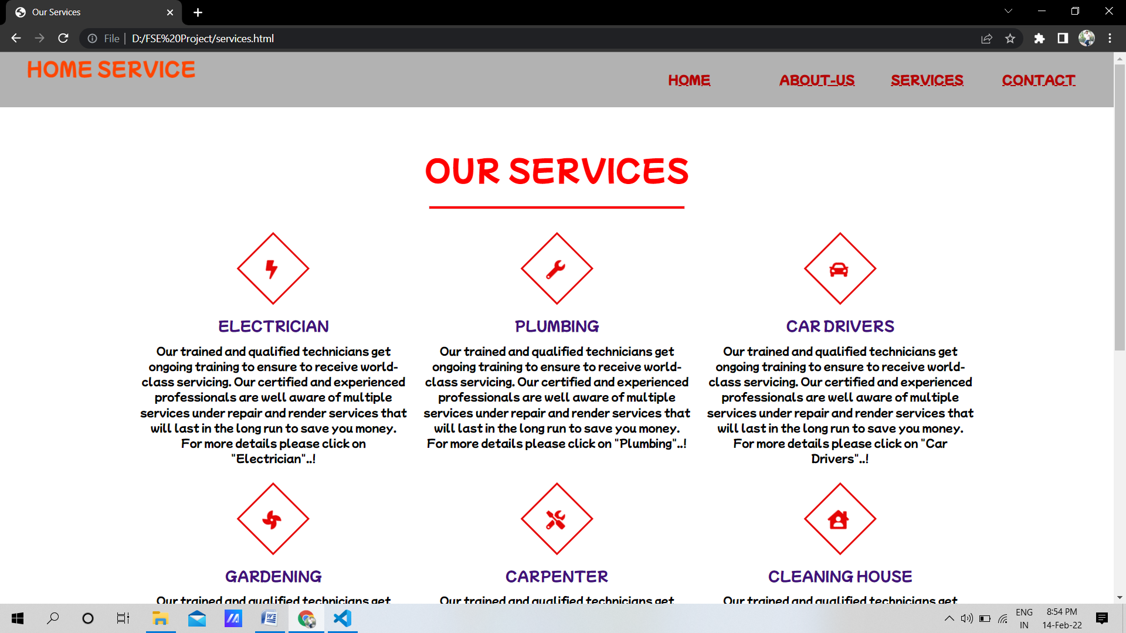**Output:-**

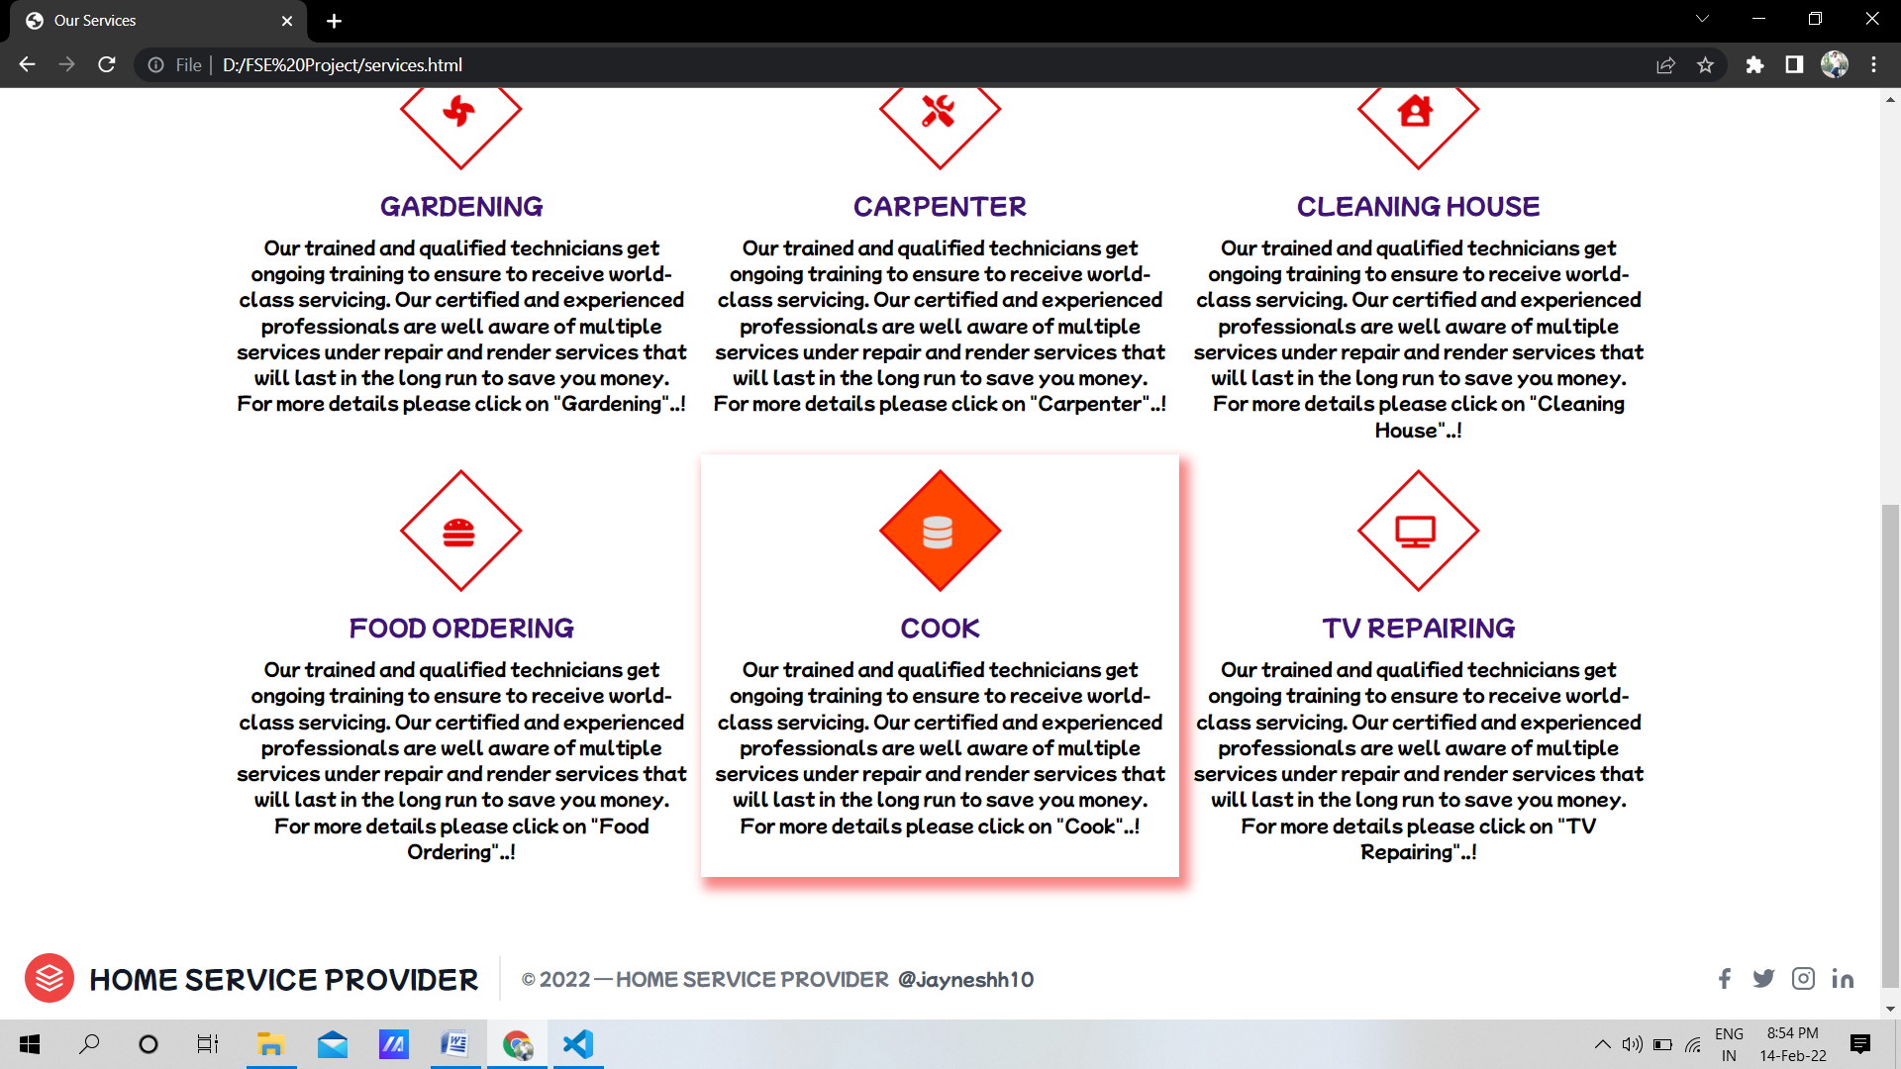

**Practical 10**

**AIM:** Define security and quality aspects of the identified module.

**THEORY:**

**QUALITY ASPECTS:**

ISO 9001: ISO 9001 sets out the criteria for a quality management system and is the only standard in the family that can be certified to (although this is not a requirement). It can be used by any organization, large or small, regardless of its field of activity. In fact, there are over one million companies and organizations in over 170 countries certified to ISO 9001. This standard is based on a number of quality management principles including a strong customer focus, the motivation and implication of top management, the process approach and continual improvement. Using ISO 9001:2015 helps ensure that customers get consistent, good quality products and services, which in turn brings many business benefits.

**BENEFITS OF ISO:9001**

An ISO 9001 Quality Management System (QMS) will help you streamline your processes, reduce errors, free up valuable management time and improve internal communications. Companies adopting this approach benefit from increased employee morale, improved customer retention and healthier revenues.

In short, through certification to ISO 9001 you demonstrate that your organization is customer focused and committed to delivering high quality services.

**Here are the top benefits of using the ISO 9001 framework:**

**1. Increased efficiency:** by following industry best-practice and focusing on quality you can reduce costs.

**2. Increased revenue:** through the reputation of ISO 9001 you can win more tenders and contracts, and by being more efficient you will also retain more customers and experience more repeat custom.

**3. Higher levels of customer satisfaction:** by understanding your customers’ needs and reducing errors you increase customer confidence in your ability to deliver products and services.

**4. Improved supplier relationships:** because ISO 9001 certification ensures best-practice processes are in place which can contribute to more efficient supply chains, certification increases their confidence in your processes.

**5. Improved employee morale:** by improving internal communications you ensure everyone works to one agenda.

**REQUIREMENTS OF ISO:9001:**

a) needs to demonstrate its ability to consistently provide products and services that meet customer and applicable statutory and regulatory requirements.

b) aims to enhance customer satisfaction through the effective application of the system, including processes for improvement of the system and the assurance of conformity to customer and applicable statutory and regulatory requirements.

All the requirements of ISO 9001:2015 are generic and are intended to be applicable to any organization, regardless of its type or size, or the products and services it provides.